Trip Dates: December 31st, 2022 - January 7th, 2023 Interviews: October 25th

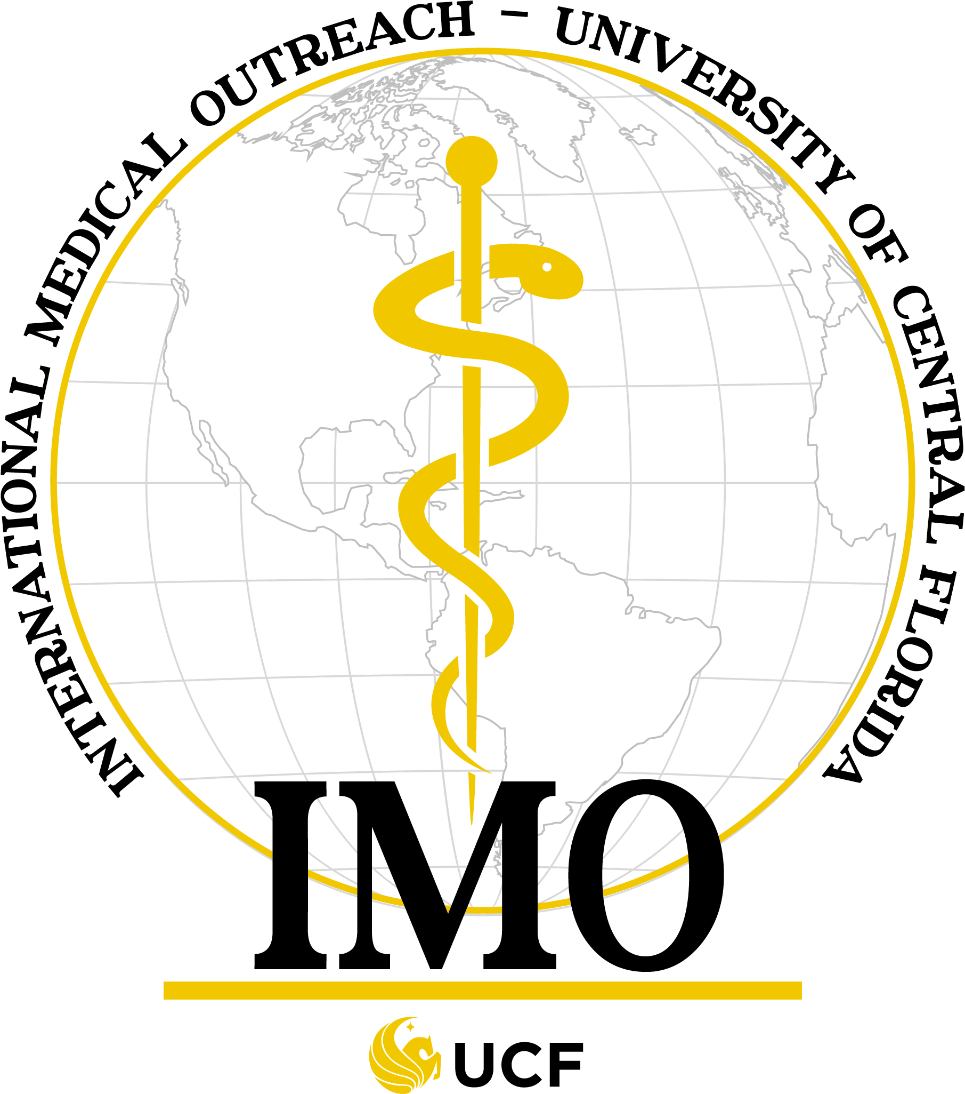
International Medical Outreach
Winter Peru Trip Application

Personal Information
Name:________________________________________ Phone: ________________________
Email: ______________________________________ Birthdate: ________________________
Do you speak any foreign languages? YES / NO
If yes , please specify ____________________________________________________________________________
Academic Information
Major(s): ___________________________ Anticipated Graduation Year: _________________
Passport Information
Do you have a valid passport? Yes / No
Country of issue: _____________________________________________________________________________
Passport Number: __________________________ Expiration Date: ______________________
IMO Involvement:
When did you join IMO (semester and year): ________________________________________
List your involvement/contribution to IMO this past semester/summer semester. _____________________________________________________________________________ _____________________________________________________________________________

Application Instructions:
Please attach a photocopy of your current resume, passport, and your updated immunization records, if available.
Answer the following essay questions on a separate, typed sheet of paper: (Maximum 250 words per question)

1. Please explain the purpose of International Medical Outreach in your own words.
2. What have you done to earn a spot on this trip?
3. What personal characteristics make you a good candidate for this trip?
4. Why do you want to attend this trip?

Please e-mail your completed application to president@imoucf.org by 5:00 pm on Friday, October 21st, 2022. If you have any questions or concerns, please contact the email above as well.

